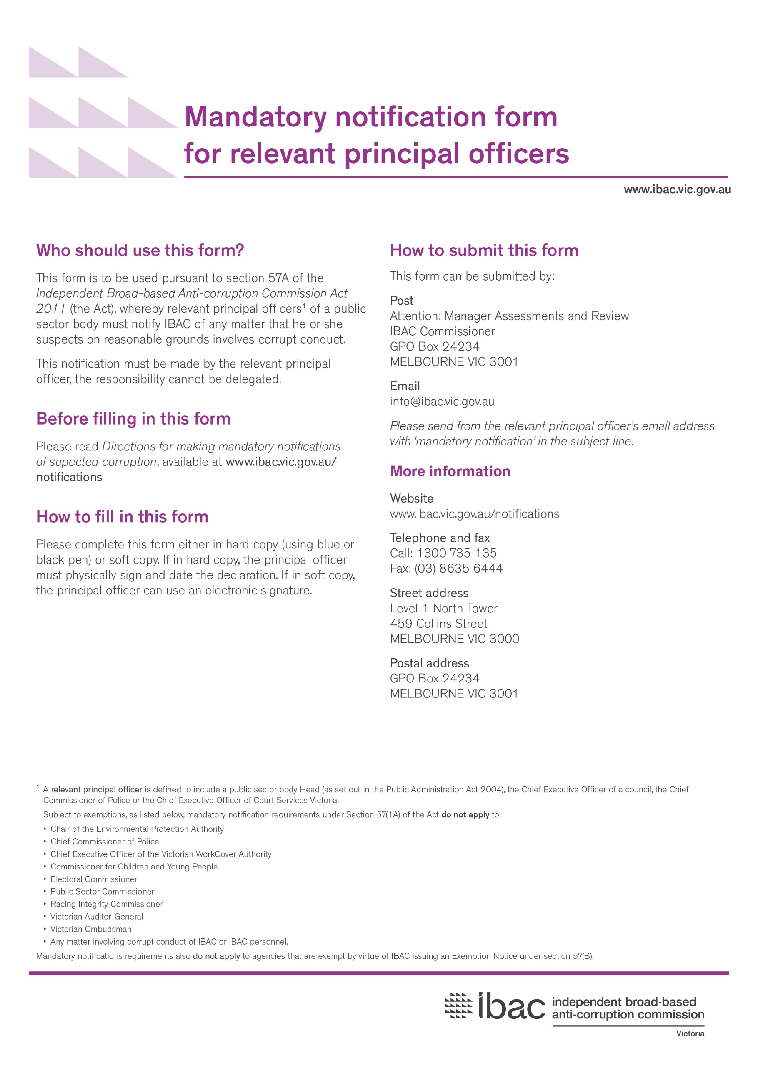

Part A – Your details

- Agency details
Name

- Principal officer details
Name
Position
Phone
Email
- Contact officer details
You may nominate an officer for IBAC to contact in regards to this notification.
Name
Position
Contact street address
Town/suburb
Postcode
Phone
Email

Part B – Information sources
If there is more than one person who brought the allegations to the Principal Officer’s attention, please download and print additional Part B forms at www.ibac.vic.gov.au

- How did your agency become aware of the alleged corrupt conduct?
- Who brought the allegations to your attention?
Name
Position
Phone
Person’s relationship to the issues raised

- Disclosures under the Public Interest Disclosures Act 2012
If your agency is not able to receive disclosures pursuant to the Public Interest Disclosures Act 2012, go to Section C.

Does this notification arise out of a disclosure made under the Public Interest Disclosures Act 2012?
☐ No go to Part C
☐ Yes go to question 7

- Is this person seeking public interest discloser status?
☐ Yes go to question 8
☐ No go to Part C

- Potential public interest discloser details
Contact street address
Town/suburb
Postcode
Phone
Email
- Has support been offered/provided to this person?
☐ Yes
Please specify:
☐ No
Please explain why not:

☐ Please check if you have attached additional Part B forms

Part C – The allegations: people
If the allegations are against more than one person, please download and print additional Part C forms at www.ibac.vic.gov.au

- Who have the allegations(s) been made against?
Name

- Is this person a public sector employee/contractor or private citizen?
☐ public sector employee Go to question 12
☐ private citizen Go to question 13

- Details for public sector employee/ contractor
Nature of the employment status
(eg employee, contractor or other)
Position
Position at time of alleged corrupt conduct
(write ‘as above’ if the same as current title)
Current work phone
Current work street address
Town/suburb
Postcode
Work address at the time of alleged corrupt conduct
(write ‘as above’ if the same as current work address)
Town/suburb
Postcode

Home street address (if known)
Town/suburb
Postcode

- Details for private citizen
Contact street address (if known)
Town/suburb
Postcode
Phone

☐ Please check if you have attached additional Part C forms

Part D – The allegations: conduct

Timing
- When did the alleged corrupt conduct come to your agency’s attention?

- When did the alleged corrupt conduct occur?

- Please provide a detailed description of the alleged corrupt conduct, including specific allegations.

☐ Please check if you have attached additional information.

Agency action
- What action, if any, has your agency taken in response to the alleged corrupt conduct?
Please note if you have reported the matter to another agency (including Victoria Police), and the response you received.
- What action, if any, do you propose in response to the alleged corrupt conduct?
Agency perspectives
- How serious is the alleged corrupt conduct, in your view?
Please advise any urgent action that you think should be taken to address the conduct, if applicable.
- Is the alleged corrupt conduct a one-off event or systemic in nature?
- Do the allegations involve money or resources?
☐ Yes
☐ No

- If yes, what is the approximate value of the money or resources involved?

- What are your agency’s policies and procedures relevant to the alleged corrupt conduct?
- Is there any other relevant information?

☐ Please check if you have attached additional information.

Part D – Declaration

☐ To the best of my knowledge, the information provided in this complaint is correct.
☐ I understand there are penalties for giving IBAC false or misleading information.

Name
Date

Signature
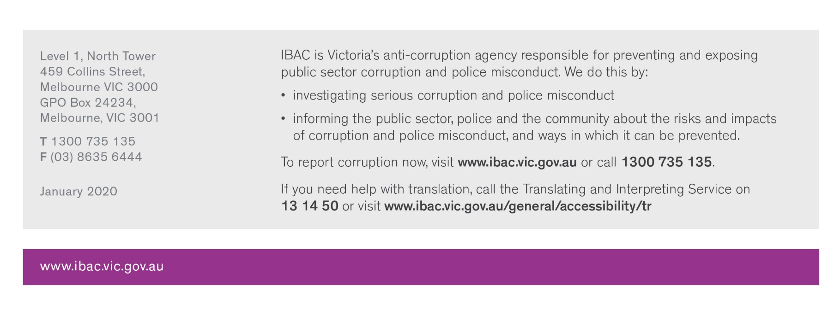
Note: a signature is not required if the relevant principal officer is emailing a mandatory notification form from their work email address.

